**Inventory Management System**

**Prepared by:-**

*ABDUL RIJAS AHAMMED-722822104005*

*ASHWIN M-722822104024*

*CIBIRAJ C-722822104034*

**Use Case Diagram of Inventory Management System**

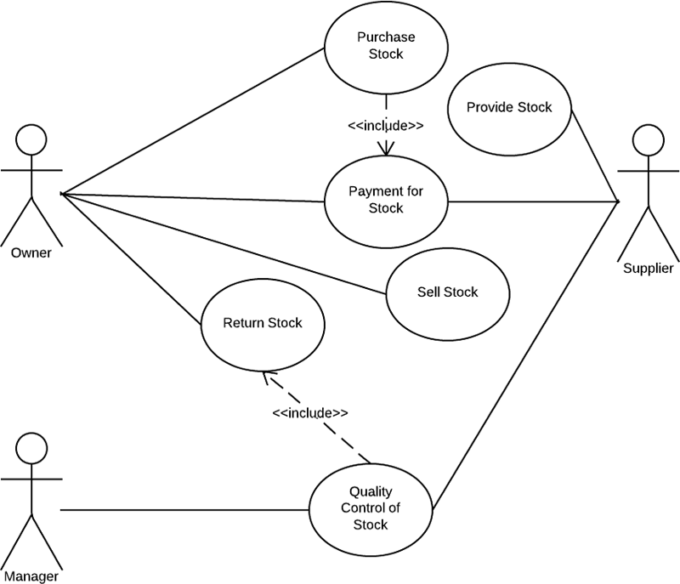

**Entity Relationship Diagram of Inventory Management System**

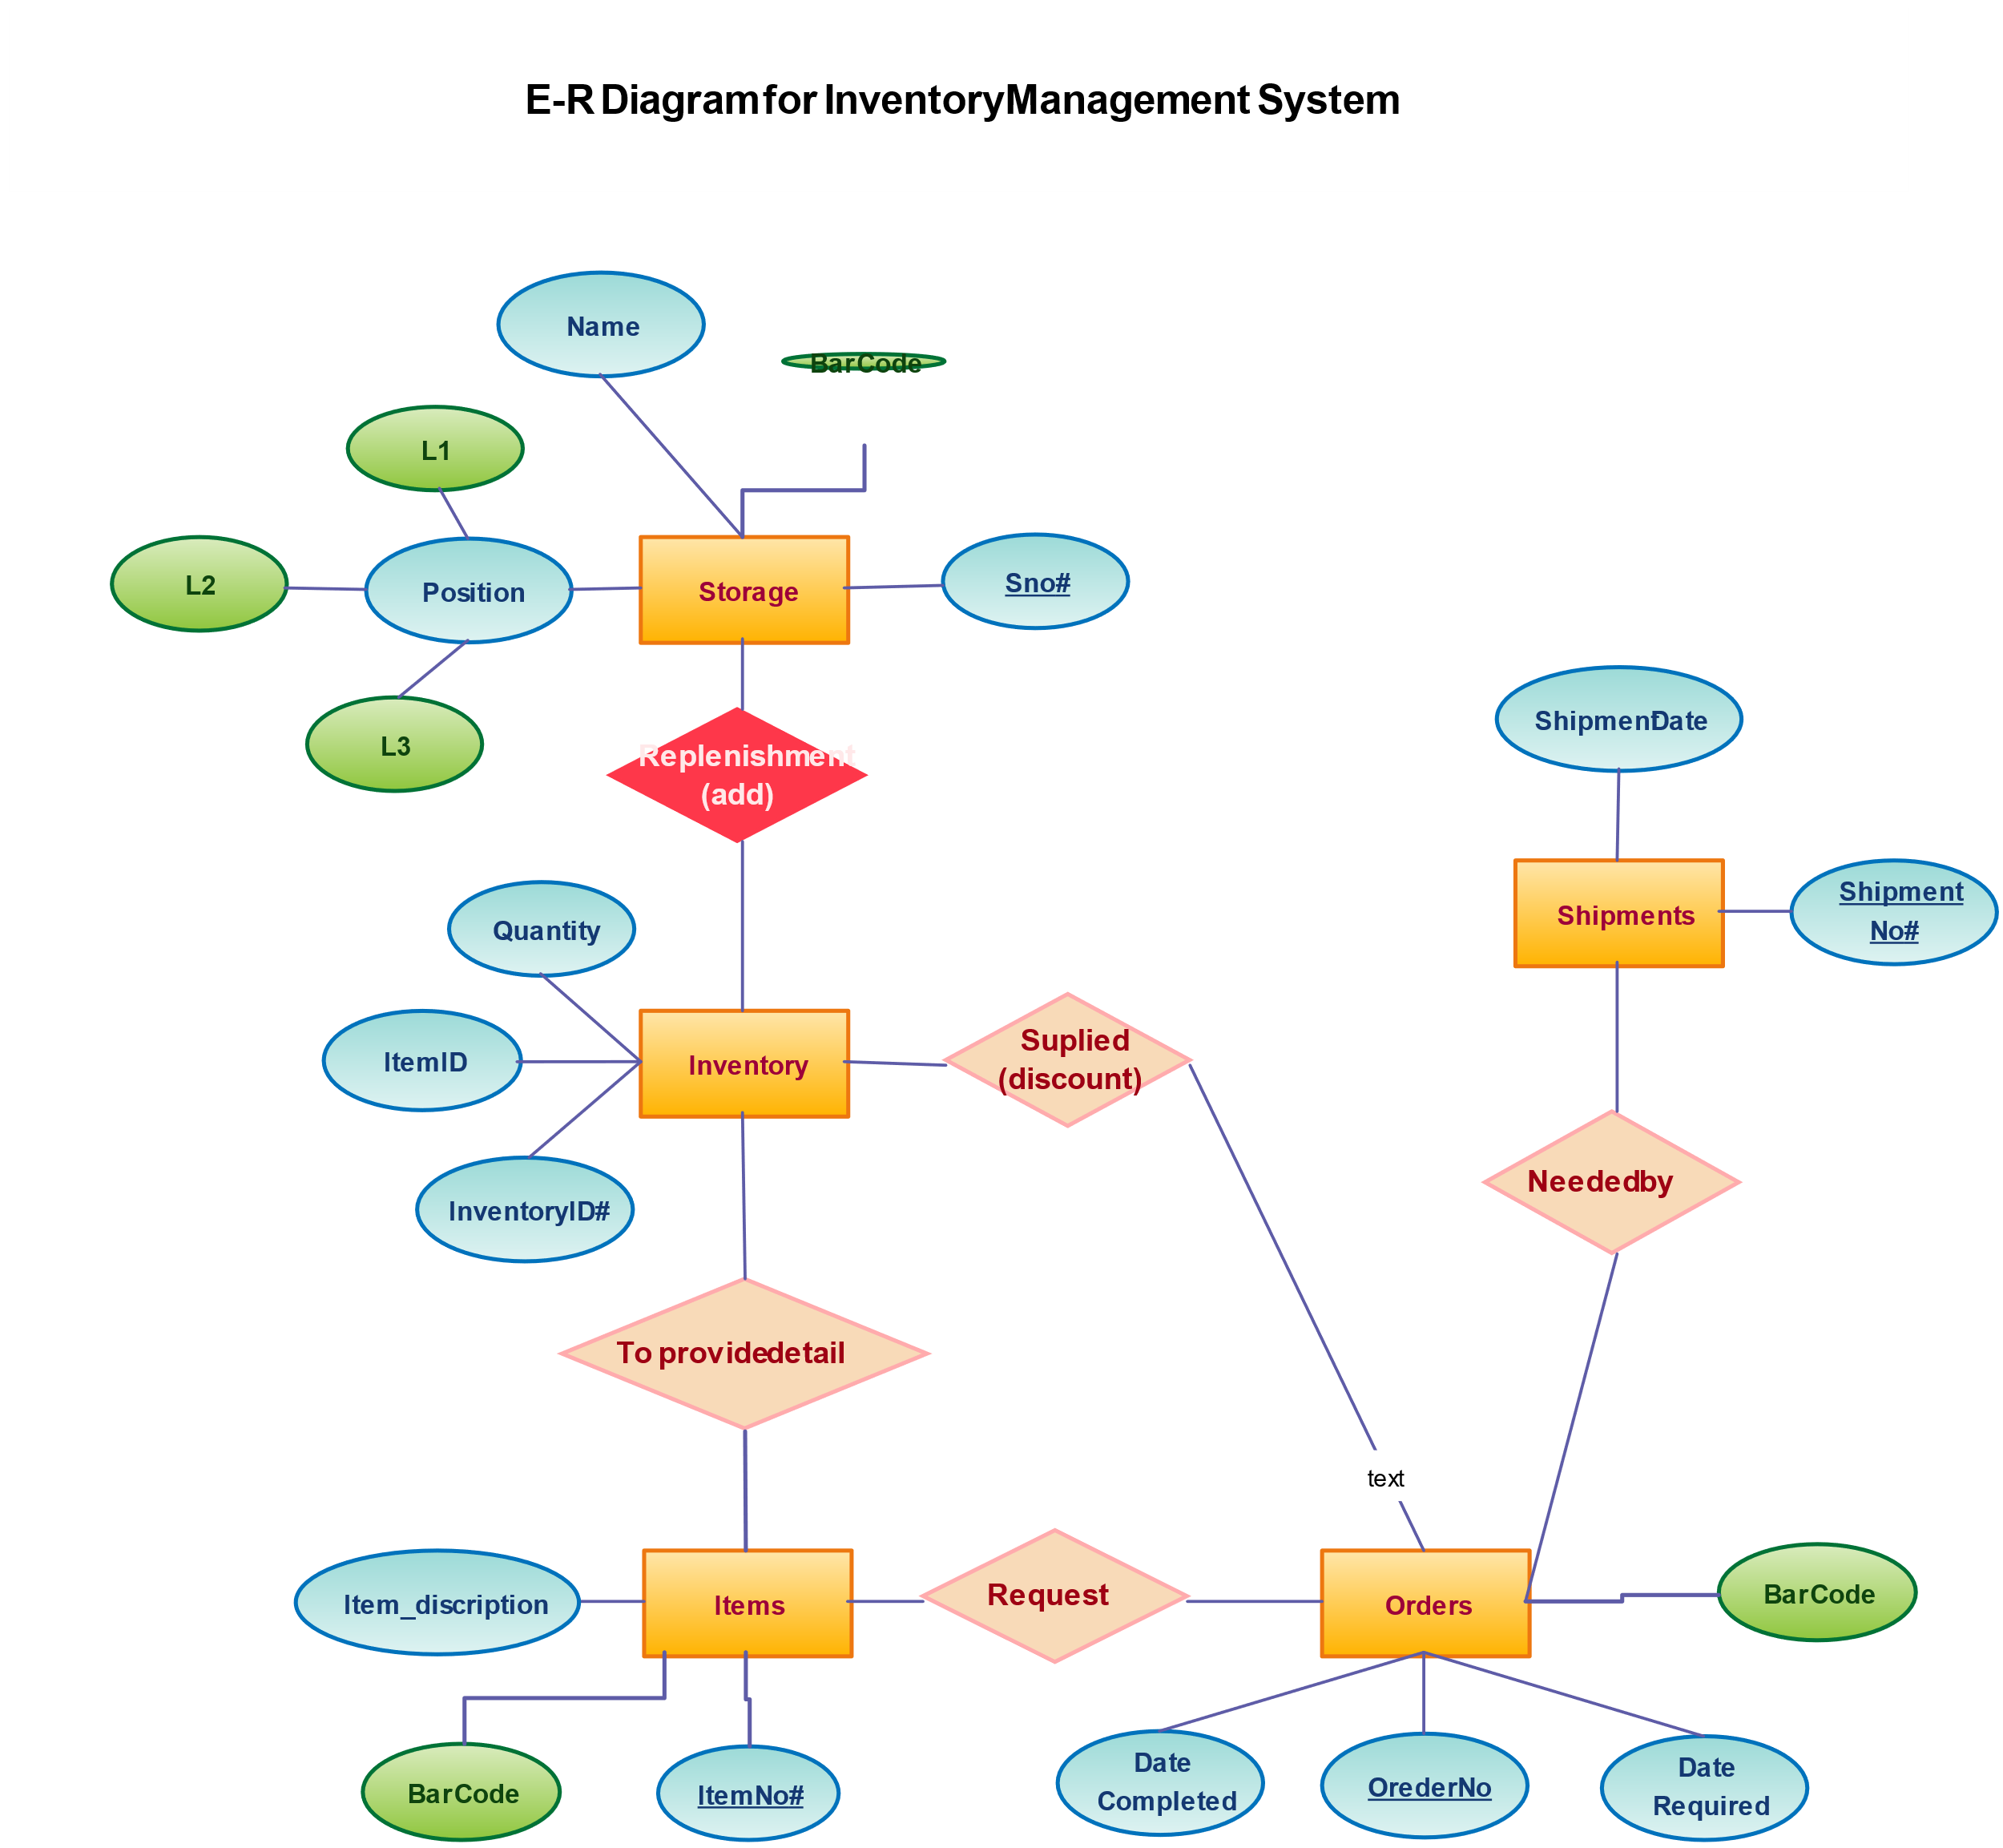

**Class Diagram:**

